

**MOBILE APPLICATION 2019**

**ECIE 4352**

**PROJECT:**

**ONLINE SHOPPING BASED APP**

**IIUM ON-SHOP**

Members:

ASYRAFUDDIN BIN MOHAMAD 1511951

AMIRUL AMIR BIN SABERI 1512037

MUHAMAD HASRIN BIN ANUAR 1514523

MOHD AMIRUL ASHRAFF BIN CHIK 1519017

Introduction

IIUM online is currently the platform used by user to promote their product or to buy product from seller. The problem face by IIUM community is that they have difficulty to promote or search the product via IIUM online.

Online shopping is the process of buying goods and services from merchant who sell on the internet. Since the emergence of the world wide web merchant has sought to sell their product to people who surf the internet. Surfer can visit web store from the comfort of their homes and shop as they sit in front of the computer or their smart phone.

IIUM students buy the variety of item from online store. In fact people can purchase just about anything from company that provide their product online. Both clothing, household appliance, and software are just some of the hundreds of product consumer can buy from online store.

Beside that, having the apps that enable IIUM community to buy and sell their products within the campus. Thus, this mobile application will help to save the money and time from going outside the campus to buy their needs.

Objective

1. To establish platform for IIUM community to do online business.
2. To make it easier for IIUM community to do online shopping inside IIUM campus.
3. To promote their product via online

User Experience

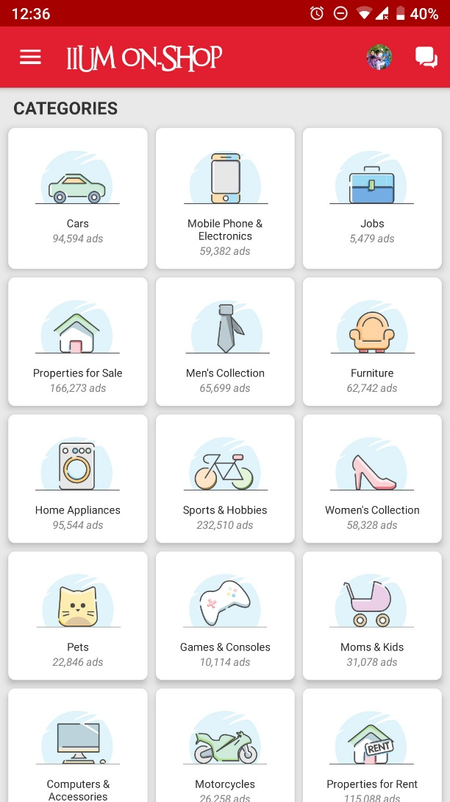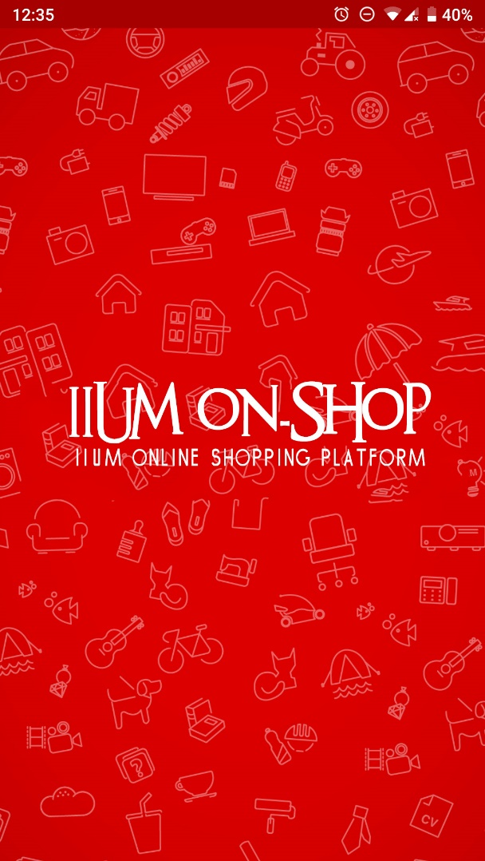

User Experience

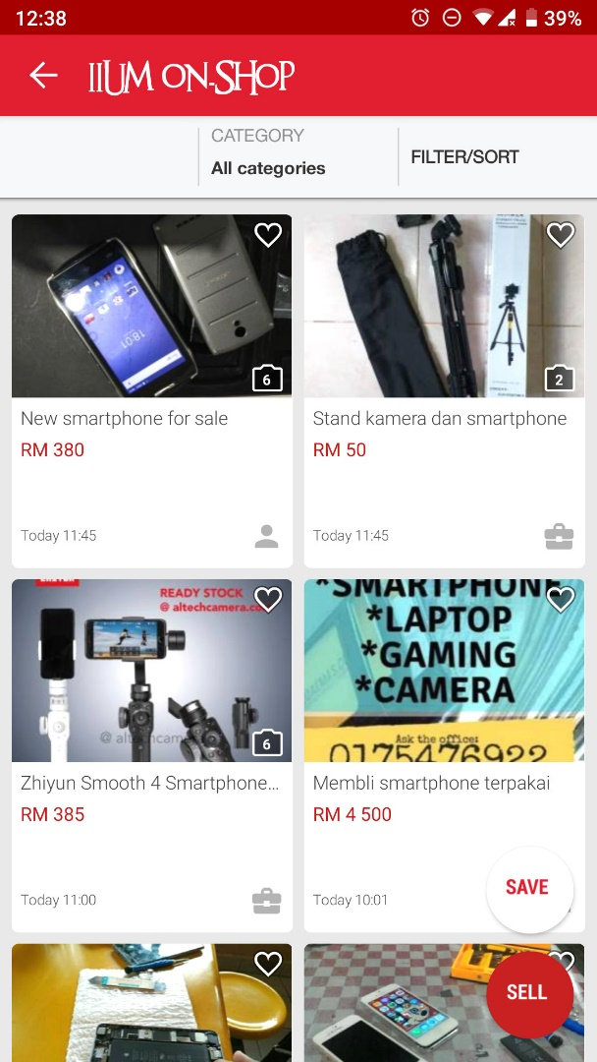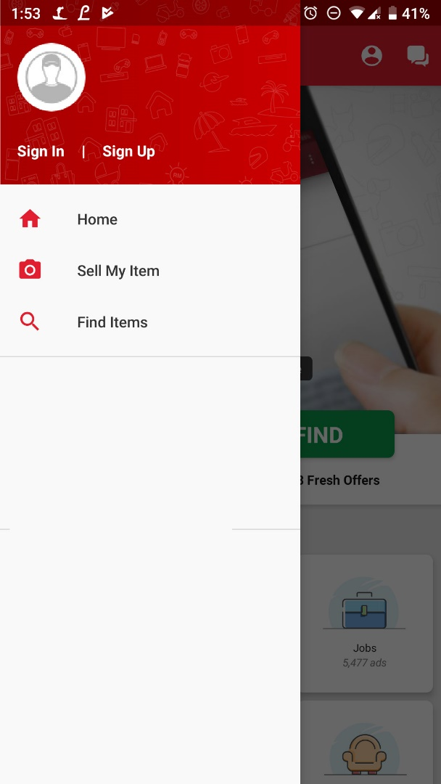

User Experience

